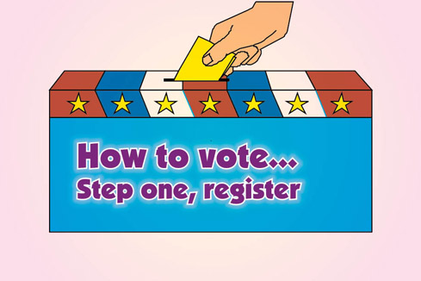

**IGE Talks -Thursday, Sept. 1 at 7 pm**

**“How to vote… step one, register.”**

This IGE Talks follows up on our popular July IGE Talks, "Meet Your Candidates for the Aug. 2 Primary

Joy Murphy of the AARP voter education program and a precinct chairperson will tell you everything you need to know about the election process. The League of Women Voters is slated to appear also. We present no candidate or proposal information, just procedural information. There’ll be time for public questions and discussion and snacks. And we will have voter registration forms.



**616-454-1642**

**Web site:** [**www.igegr.org**](http://www.igegr.org)

**www.igetalks.org**

**Email:** [**info@igegr.org**](mailto:info@igegr.org)

**www.facebook.com/InstituteforGlobalEducation**