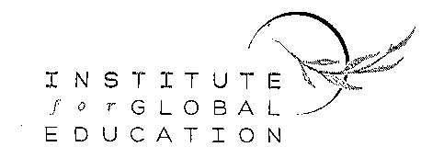**1118 Wealthy St SE**

**Grand Rapids, MI 49506**

**616-454-1462**

**501 (c) 3**

**Web site: www.igegr.org**

**Email: info@igegr.org**

**Facebook: www.facebook.com/InstituteforGlobalEducation**

**Crafting Better Communities (formerly Sewing Circle)**

**We are returning Tuesdays from 2pm to 7pm.**

**Currently scheduled on Sept. 11th, 18th, 25th, Oct. 1st & 8th, 2020**

**Face masks (we have available) and social distancing required.**

**At IGE office: 1118 Wealthy SE, Grand Rapids**

**Parking behind building (paid until 5pm), near 4, 5 & 6 bus lines**

**CREATE: arts, crafts, sew, knit, crochet, draw, color, teach, learn, etc., or just talk. Sewing machine, button maker, art & sign supplies, kid’s stuff, worktables. Collaborative projects welcome.**

**BOOKS: including “Crafting the Resistance”, “Doomsday Knits”, “Re-Sew”, “Sewing Green”. On-line resources.**

**Come and go as you like. Coffee & tea. No charge but goodwill donations appreciated.**

**To schedule special projects like sign making, workshops, individual help or other times contact Kate at 773-220-0847**